### **Reservation Cancellation Prediction**

1. **INTRODUCTION**
   1. **Overview**

#### The aim of this project is to predict a hotel booking׳s likelihood to be canceled. The data includes hotel booking information of hotel total 18 features in the dataset. The model aims to understand bookings and predict successfully based on booking characteristics, whether a customer has a higher chance of cancellation.This model will be really useful in identifying potential customers who can cancel and help hotels actively incentivise/penalise the customers depending on the marketing strategy.

**1.2 Purpose**

We have developed a model which can predict whether the made reservation will be cancelled. This model can be used by hotel owners and managers for predicting the booking cancellations. This model does not ask for personalised data such as name, age, gender, religion, address, etc. You can use this web application anytime you receive a reservation, and the model will the output for the reservation cancellation.This model should be used for reducing losses by the hotel owners and should not be the only factor for making important decisions.

1. **LITERATURE SURVEY**
   1. **Existing Problem**

In today’s world, people take high amounts of responsibilities. These high responsibilities lead to stress and wear out. To relax everybody thinks of going on a holiday or vacation. Reservations are made for hotels at some destination. It is not necessary that once the reservation is made, the person who made the reservation will show up at the day of reservation. They might have to cancel it due to unforeseen circumstances. These reservation cancellations are a huge problem faced by the hotel owners or managers as they are at a loss because they cannot take another booking on the same day.

**2.2 Proposed Solution**

A literature survey for reservation cancellation prediction project would involve researching and reviewing existing studies, articles, and other publications on the topic of reservations. The survey would aim to gather information on current classification systems, their strengths and weaknesses, and any gaps in knowledge that the project could address. The literature survey would also look at the methods and techniques used in previous reservation cancellation prediction projects, and any relevant data or findings that could inform the design and implementation of the current project.

1. **THEORITICAL ANALYSIS** 
   1. **Block Diagram**

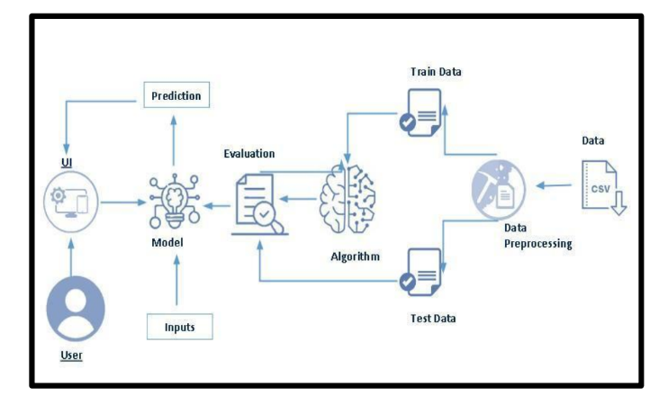

* 1. **Hardware / Software Designing**

**Hardware Requirement**

Processor : Pentium IV

RAM : 4 GB

HDD : 500 MB free space

Monitor : SVGA 16/32 bit color with 1024 by 768 resolutions

CD-R/W Drive : 52X CD/RW

Printer : Standard

**Software Requirement**

* ****Programming Language:****

**Python is a popular choice for data science and machine learning tasks. You can use Python for both data preprocessing and building predictive models.**

* ****Integrated Development Environment (IDE):****

**Choose an IDE such as Jupyter Notebook, PyCharm, or Visual Studio Code for coding, experimenting with data, and developing machine learning models.**

* ****Data Manipulation and Analysis:****

**Pandas: A Python library for data manipulation and analysis.**

* **NumPy: For numerical computing and handling arrays.**
* ****Data Visualization:****

**Matplotlib: For creating static, interactive, and animated visualizations**

**Seaborn: A high-level interface to Matplotlib for creating attractive statistical graphics.**

**Plotly: For interactive and web-based visualizations.**

* ****Machine Learning and Predictive Modeling:****

**Scikit-learn: A machine learning library that provides tools for classification and regression tasks.**

**XGBoost, LightGBM, or CatBoost: Gradient boosting libraries known for their high predictive accuracy.**

1. **EXPERIMENTAL INVESTIGATION**

A literature survey for reservation cancellation prediction project would involve researching and reviewing existing studies, articles, and other publications on the topic of reservations. The survey would aim to gather information on current classification systems, their strengths and weaknesses, and any gaps in knowledge that the project could address. The literature survey would also look at the methods and techniques used in previous reservation cancellation prediction projects, and any relevant data or findings that could inform the design and implementation of the current project.

1. **FLOW CHART**

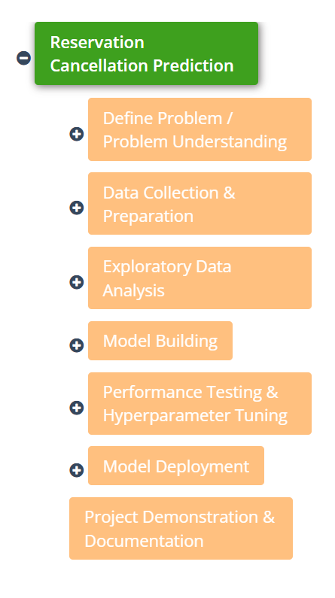

1. **RESULT**

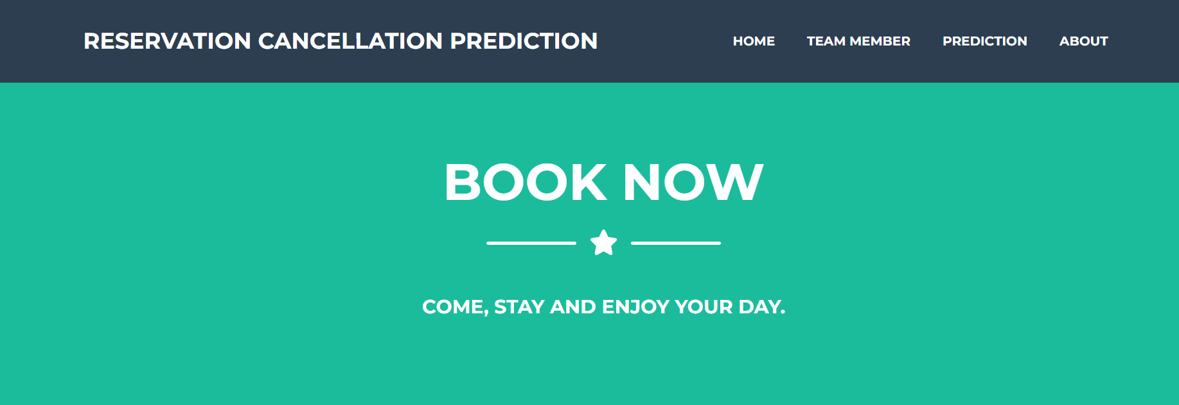

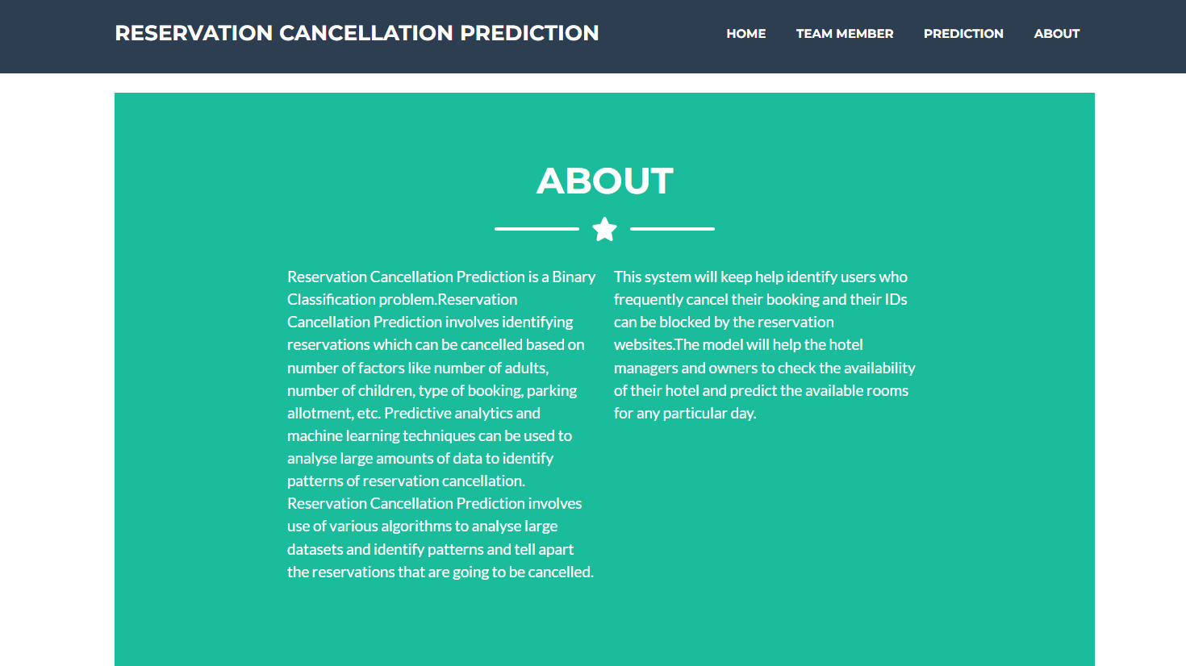

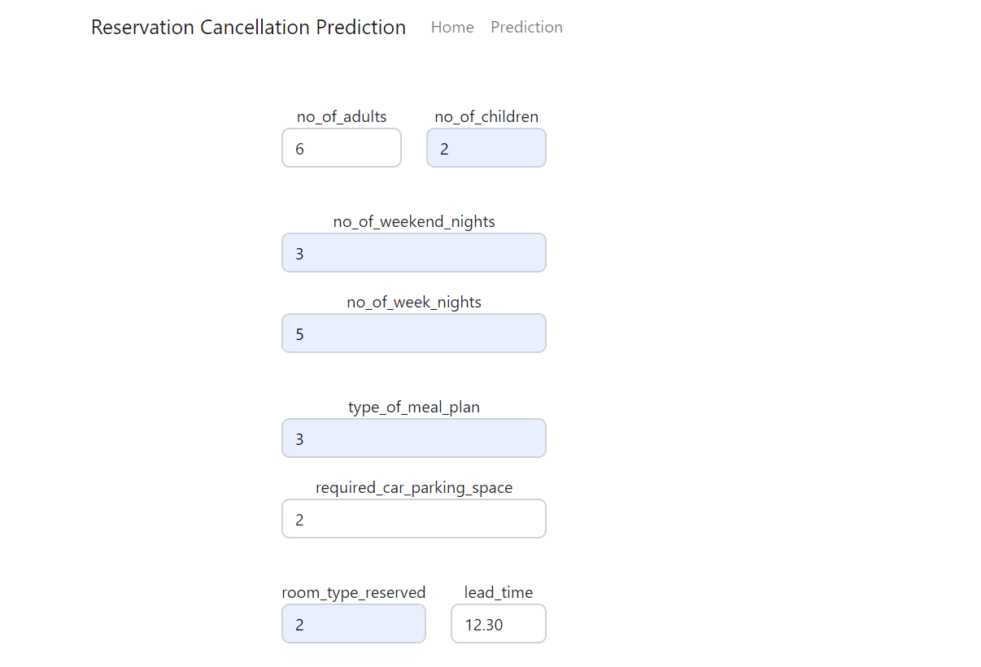

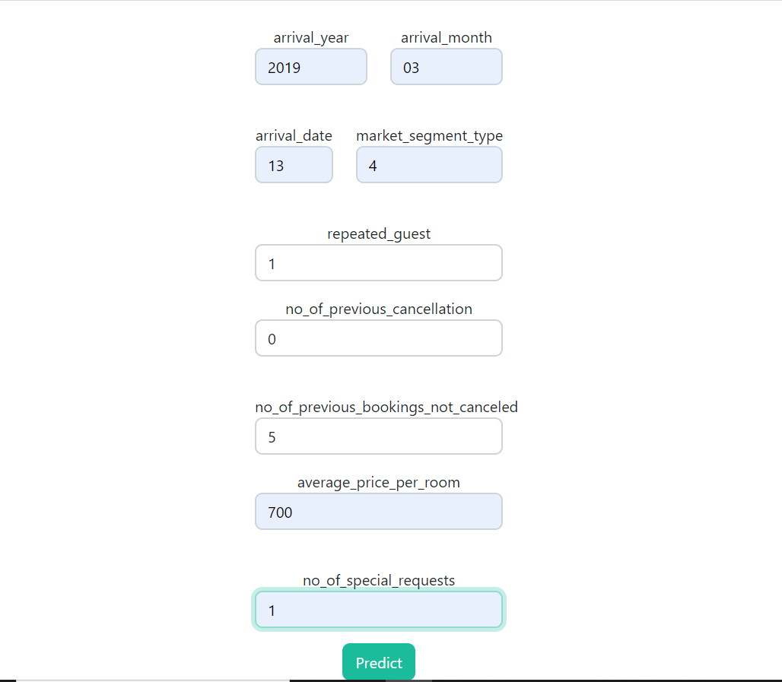

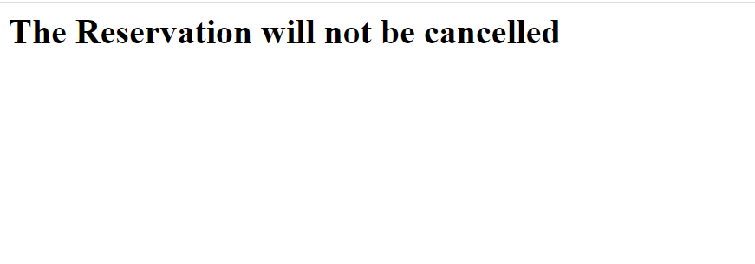

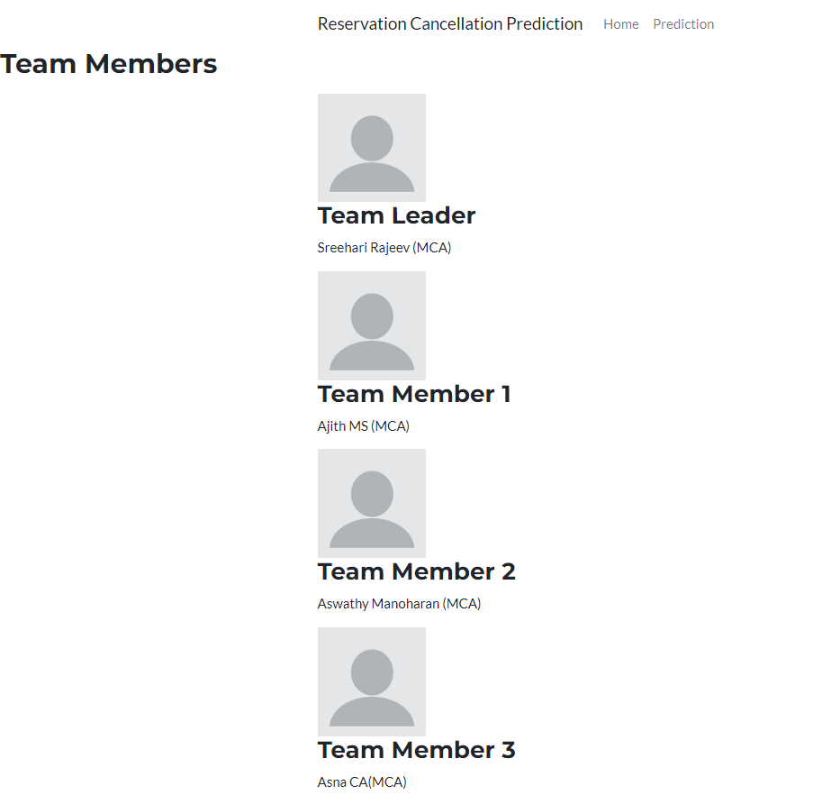

1. **ADVANTAGES AND DISADVANTAGES**

**Advantages:**

* Improved Revenue Management
* Enhanced Customer Experience
* Data-Driven Decision Making
* Customization
* Automation
* Scalability

**Disadvantages:**

* Data Quality
* Model Complexity
* Resource Requirements
* Model Drift
* Privacy and Security
* False Positives

1. **APPLICATIONS**

Reservation cancellation prediction can be applied in various industries and contexts to optimize resource allocation, improve customer satisfaction, and enhance revenue management. Here are some key applications where reservation cancellation prediction can be used:

* **Hospitality and Hotels**
* **Airlines:**
* **Restaurants**
* **Car Rentals**
* **Online Ticket Sales**

1. **CONCLUSION**

Reservation cancellation prediction is a valuable application of data analysis and machine learning techniques in the hospitality and booking industry. By implementing a well-structured prediction system, businesses can make informed decisions regarding overbooking, resource allocation, and revenue optimization.Reservation cancellation prediction is a valuable tool for optimizing the operations and revenue of businesses in the hospitality and booking industry. It allows organizations to make data-driven decisions, reduce revenue loss due to cancellations, and enhance customer satisfaction by managing reservations more effectively.

1. **FUTURE SCOPE**

The future scope of reservation cancellation prediction projects is bright and dynamic. As businesses strive to optimize their operations, customer experiences, and revenue management, the use of predictive analytics in this context will continue to evolve and expand, offering new opportunities for innovation and improved decision-making.

1. **BIBLOGRAPHY**

You must have the prior knowledge of the following topics to complete this project:

* ML Concepts:
* Supervised learning: <https://www.javatpoint.com/supervised-machine-learning>
* Linear Regression: <https://www.javatpoint.com/linear-regression-in-machine-learning>
* SVM: <https://www.javatpoint.com/machine-learning-support-vector-machine>
* Decision tree: <https://www.javatpoint.com/machine-learning-decision-tree>
* Random forest: <https://www.javatpoint.com/machine-learning-random-forest>
* Evaluation metrics: <https://www.analyticsvidhya.com/blog/2019/08/11-important-modelevaluation-error-metrics/>
* Regularisation: <https://www.javatpoint.com/regularization-in-machine-learning>
* Flask Basics: <https://www.youtube.com/watch?v=lj4I_CvBnt0>

1. **APPENDIX**

**App.py**

from flask import Flask,render_template,request

import pandas as pd

import pickle

app=Flask(__name__)

model=pickle.load(open('model.pkl','rb'))

@app.route('/')

@app.route('/home',methods=['GET', 'POST'])

def Home():

return render_template("home.html")

@app.route('/details',methods=['GET', 'POST'])

def Pred():

return render_template("details.html")

@app.route('/predict',methods = ['GET','POST'])

def predict():

no_of_adults = request.form['no_of_adults']

no_of_children = request.form['no_of_children']

no_of_weekend_nights = request.form['no_of_weekend_nights']

no_of_week_nights = request.form['no_of_week_nights']

type_of_meal_plan=request.form['type_of_meal_plan']

required_car_parking_space = request.form['required_car_parking_space']

room_type_reserved = request.form['room_type_reserved']

lead_time = request.form['lead_time']

arrival_year = request.form['arrival_year']

arrival_month = request.form['arrival_month']

arrival_date = request.form['arrival_date']

market_segment_type = request.form['market_segment_type']

repeated_guest=request.form['repeated_guest']

no_of_previous_cancellations = request.form['no_of_previous_cancellations']

no_of_previous_bookings_not_canceled=request.form['no_of_previous_bookings_not_canceled']

avg_price_per_room=request.form['avg_price_per_room']

no_of_special_requests=request.form['no_of_special_requests']

total=[[no_of_adults,no_of_children,no_of_weekend_nights,no_of_week_nights,type_of_meal_plan,required_car_parking_space,room_type_reserved,

lead_time,arrival_year,arrival_month,arrival_date,market_segment_type,repeated_guest,

no_of_previous_cancellations,no_of_previous_bookings_not_canceled,avg_price_per_room,no_of_special_requests]]

d1=pd.DataFrame(data=total,columns=['no_of_adults','no_of_children','no_of_weekend_nights',

'no_of_week_nights','type_of_meal_plan','required_car_parking_space','room_type_reserved',

'lead_time','arrival_year','arrival_month','arrival_date','market_segment_type','repeated_guest',

'no_of_previous_cancellations','no_of_previous_bookings_not_canceled',

'avg_price_per_room','no_of_special_requests'])

prediction=model.predict(d1)

prediction=prediction[0]

if prediction== 0:

return render_template('results.html',prediction_text="The Reservation will not be cancelled")

else:

return render_template('results.html',prediction_text="The Reservation will be cancelled")

if __name__=='__main__':

app.run(debug=True)

**home.html**

<!DOCTYPE html>

<html lang="en">

<head>

<meta charset="utf-8" />

<meta name="viewport" content="width=device-width, initial-scale=1, shrink-to-fit=no" />

<meta name="description" content="" />

<meta name="author" content="" />

<title>Home</title>

<!-- Favicon-->

<link rel="icon" type="image/x-icon" href="assets/favicon.ico" />

<!-- Font Awesome icons (free version)-->

<script src="https://use.fontawesome.com/releases/v6.3.0/js/all.js" crossorigin="anonymous"></script>

<!-- Google fonts-->

<link href="https://fonts.googleapis.com/css?family=Montserrat:400,700" rel="stylesheet" type="text/css" />

<link href="https://fonts.googleapis.com/css?family=Lato:400,700,400italic,700italic" rel="stylesheet" type="text/css" />

<!-- Core theme CSS (includes Bootstrap)-->

<link rel="stylesheet" type="text/css"href="{{ url_for('static', filename= 'styles2.css') }}">

</head>

<body id="page-top">

<!-- Navigation-->

<nav class="navbar navbar-expand-lg bg-secondary text-uppercase fixed-top" id="mainNav">

<div class="container">

<a class="navbar-brand" href="#page-top">Reservation Cancellation Prediction</a>

<button class="navbar-toggler text-uppercase font-weight-bold bg-primary text-white rounded" type="button" data-bs-toggle="collapse" data-bs-target="#navbarResponsive" aria-controls="navbarResponsive" aria-expanded="false" aria-label="Toggle navigation">

Menu

<i class="fas fa-bars"></i>

</button>

<div class="collapse navbar-collapse" id="navbarResponsive">

<ul class="navbar-nav ms-auto">

<li class="nav-item mx-0 mx-lg-1"><a class="nav-link py-3 px-0 px-lg-3 rounded" href="/home">Home</a></li>

<li class="nav-item mx-0 mx-lg-1"><a class="nav-link py-3 px-0 px-lg-3 rounded" href="{{url_for('Pred')}}">Prediction</a></li>

<li class="nav-item mx-0 mx-lg-1"><a class="nav-link py-3 px-0 px-lg-3 rounded" href="#about">About</a></li>

</ul>

</div>

</div>

</nav>

<!-- Masthead-->

<header class="masthead bg-primary text-white text-center">

<div class="container d-flex align-items-center flex-column">

<!-- Masthead Heading-->

<h1 class="masthead-heading text-uppercase mb-0">Home

<!-- Icon Divider-->

<div class="divider-custom divider-light">

<div class="divider-custom-line"></div>

<div class="divider-custom-icon"><i class="fas fa-star"></i></div>

<div class="divider-custom-line"></div>

</div>

<!-- Masthead Subheading-->

<p class="masthead-subheading font-weight-light mb-0">Come, stay and enjoy your day.</p>

</div>

</header>

<!-- Portfolio Section-->

<section class="page-section portfolio" id="portfolio">

<div class="container">

<!-- Portfolio Section Heading-->

<h2 class="page-section-heading text-center text-uppercase text-secondary mb-0"></h2>

<!-- About Section-->

<section class="page-section bg-primary text-white mb-0" id="about">

<div class="container">

<!-- About Section Heading-->

<h2 class="page-section-heading text-center text-uppercase text-white">About</h2>

<!-- Icon Divider-->

<div class="divider-custom divider-light">

<div class="divider-custom-line"></div>

<div class="divider-custom-icon"><i class="fas fa-star"></i></div>

<div class="divider-custom-line"></div>

</div>

<!-- About Section Content-->

<div class="row">

<div class="col-lg-4 ms-auto"><p class="lead">Reservation Cancellation Prediction is a Binary Classification problem.Reservation Cancellation Prediction involves identifying reservations which can be cancelled based on number of factors like number of adults, number of children, type of booking, parking allotment, etc. Predictive analytics and machine learning techniques can be used to analyse large amounts of data to identify patterns of reservation cancellation. Reservation Cancellation Prediction involves use of various algorithms to analyse large datasets and identify patterns and tell apart the reservations that are going to be cancelled.</p></div>

<div class="col-lg-4 me-auto"><p class="lead">This system will keep help identify users who frequently cancel their booking and their IDs can be blocked by the reservation websites.The model will help the hotel managers and owners to check the availability of their hotel and predict the available rooms for any particular day.</p></div>

</section>

<!-- Bootstrap core JS-->

<script src="https://cdn.jsdelivr.net/npm/bootstrap@5.2.3/dist/js/bootstrap.bundle.min.js"></script>

<!-- Core theme JS-->

<script src="js/scripts.js"></script>

<!-- * * * * * * * * * * * * * * * * * * * * * * * * * * * * * * * * * * * * * * * *-->

<!-- * * SB Forms JS * *-->

<!-- * * Activate your form at https://startbootstrap.com/solution/contact-forms * *-->

<!-- * * * * * * * * * * * * * * * * * * * * * * * * * * * * * * * * * * * * * * * *-->

<script src="https://cdn.startbootstrap.com/sb-forms-latest.js"></script>

</body>

</html>

**details.html**

<!doctype html>

<html>

<head>

<!-- Required meta tags -->

<meta charset="utf-8">

<meta name="viewport" content="width=device-width, initial-scale=1, shrink-to-fit=no">

<!-- awesone fonts css-->

<link href="../static/css/font-awesome.css" rel="stylesheet" type="text/css">

<!-- owl carousel css-->

<link rel="stylesheet" href="../static/owl-carousel/assets/owl.carousel.min.css" type="text/css">

<!-- Bootstrap CSS -->

<link rel="stylesheet" href="../static/css/bootstrap.min.css">

<!-- custom CSS -->

<link rel="stylesheet" type="text/css"href="{{ url_for('static', filename= 'styles2.css') }}">

<title>Prediction</title>

</head>

<body>

<nav class="navbar navbar-expand-lg navbar-light bg-light bg-transparent" id="gtco-main-nav">

<div class="container"><a class="navbar-brand">Reservation Cancellation Prediction</a>

<button class="navbar-toggler" data-target="#my-nav" onclick="myFunction(this)" data-toggle="collapse"><span

class="bar1"></span> <span class="bar2"></span> <span class="bar3"></span></button>

<div id="my-nav" class="collapse navbar-collapse">

<ul class="navbar-nav mr-auto">

<li class="nav-item"><a class="nav-link" href="/home">Home</a></li>

<li class="nav-item"><a class="nav-link" href="/predict">Prediction</a></li>

</ul>

</div>

</div>

</nav>

<div class="container-fluid gtco-banner-area">

<div class="container">

<div class="row">

<div class="col-md-6">

<section>

<div class="container">

<div class="row">

<center>

<div class=" col-lg-7 px-5 pt-5">

<div class="divider"></div>

<form action="/predict" method="POST">

<!-- satisfaction_level -->

<div class="row mb-4">

<div class="col">

<div class="form-outline">

<p>no_of_adults<input type="text" placeholder=" " class="form-control" name='no_of_adults'></p>

</div>

</div>

<div class="col">

<div class="form-outline">

<!-- last_evaluation -->

<p>no_of_children<input type="text" placeholder="" class="form-control" name='no_of_children'></p>

</div>

</div>

</div>

<div class="row mb-4">

<div class="col">

<div class="form-outline">

<!-- number_project -->

<p>no_of_weekend_nights<input type="text" placeholder="" class="form-control" name='no_of_weekend_nights'></p>

</div>

</div>

<div class="col">

<div class="form-outline">

<!-- average_monthly_hours -->

<p>no_of_week_nights<input type="text" placeholder="" class="form-control" name='no_of_week_nights'></p>

</div>

</div>

</div>

<div class="row mb-4">

<div class="col">

<div class="form-outline">

<!-- time_spend_company -->

<p>type_of_meal_plan<input type="text" placeholder="" class="form-control" name='type_of_meal_plan'></p>

</div>

</div>

<div class="col">

<div class="form-outline">

<!-- Work_accident -->

<p>required_car_parking_space<input type="text" placeholder="" class="form-control" name='required_car_parking_space'></p>

</div>

</div>

</div>

<div class="row mb-4">

<div class="col">

<div class="form-outline">

<!-- left -->

<p>room_type_reserved<input type="text" placeholder="" class="form-control" name='room_type_reserved'></p>

</div>

</div>

<div class="col">

<div class="form-outline">

<!-- promotion_last_5years -->

<p>lead_time<input type="text" placeholder="" class="form-control" name='lead_time'></p>

</div>

</div>

</div>

<div class="row mb-4">

<div class="col">

<div class="form-outline">

<!-- left -->

<p>arrival_year<input type="text" placeholder="" class="form-control" name='arrival_year'></p>

</div>

</div>

<div class="col">

<div class="form-outline">

<!-- promotion_last_5years -->

<p>arrival_month<input type="text" placeholder="" class="form-control" name='arrival_month'></p>

</div>

</div>

</div>

<div class="row mb-4">

<div class="col">

<div class="form-outline">

<!-- left -->

<p>arrival_date<input type="text" placeholder="" class="form-control" name='arrival_date'></p>

</div>

</div>

<div class="col">

<div class="form-outline">

<!-- promotion_last_5years -->

<p>market_segment_type<input type="text" placeholder="" class="form-control" name='market_segment_type'></p>

</div>

</div>

</div>

<div class="row mb-4">

<div class="col">

<div class="form-outline">

<!-- left -->

<p>repeated_guest<input type="text" placeholder="" class="form-control" name='repeated_guest'></p>

</div>

</div>

<div class="col">

<div class="form-outline">

<!-- promotion_last_5years -->

<p>no_of_previous_cancellation<input type="text" placeholder="" class="form-control" name='no_of_previous_cancellations'></p>

</div>

</div>

</div>

<div class="row mb-4">

<div class="col">

<div class="form-outline">

<!-- left -->

<p>no_of_previous_bookings_not_canceled<input type="text" placeholder="" class="form-control" name='no_of_previous_bookings_not_canceled'></p>

</div>

</div>

<div class="col">

<div class="form-outline">

<!-- promotion_last_5years -->

<p>average_price_per_room<input type="text" placeholder="" class="form-control" name='avg_price_per_room'></p>

</div>

</div>

</div>

<div class="col">

<div class="form-outline">

<!-- promotion_last_5years -->

<p>no_of_special_requests<input type="text" placeholder="" class="form-control" name='no_of_special_requests'></p>

</div>

</div>

<!-- Submit button -->

<button type="submit" class="btn btn-primary" value="pred" <a href="/predict">Predict</a></button>

</form>

</div>

</center>

</div>

</div>

</section>

</div>

</div>

</div>

</div>

<!-- Optional JavaScript -->

<!-- jQuery first, then Popper.js, then Bootstrap JS -->

<script src="../static/js/jquery-3.3.1.slim.min.js"></script>

<script src="../static/js/popper.min.js"></script>

<script src="../static/js/bootstrap.min.js"></script>

<!-- owl carousel js-->

<script src="../static/owl-carousel/owl.carousel.min.js"></script>

<script src="../static/js/main.js"></script>

</body>

</html>